***Design and Analysis of Algorithms CS575, Spring 2023***

Theory Assignment 2.1

**Due on 3/2/2023 (Thursday)**

1. (16 points) Use the iteration method or recursion tree method to solve the following recurrence equation.
   1. (8 points)

𝑇(𝑛 − 1) + 𝑛 𝑖𝑓 (𝑛 > 1)

𝑇 (𝑛) = {

1 𝑖𝑓 (𝑛 = 1)

* 1. (8 points) You can assume *n*1/ 2*k*  2 for some integers *n* and *k.*

T(n) = $\left\{\begin{aligned}0 if n=2 \\ T\left(\sqrt{n}\right)+1 if n>2 \\ \end{aligned}\right.$

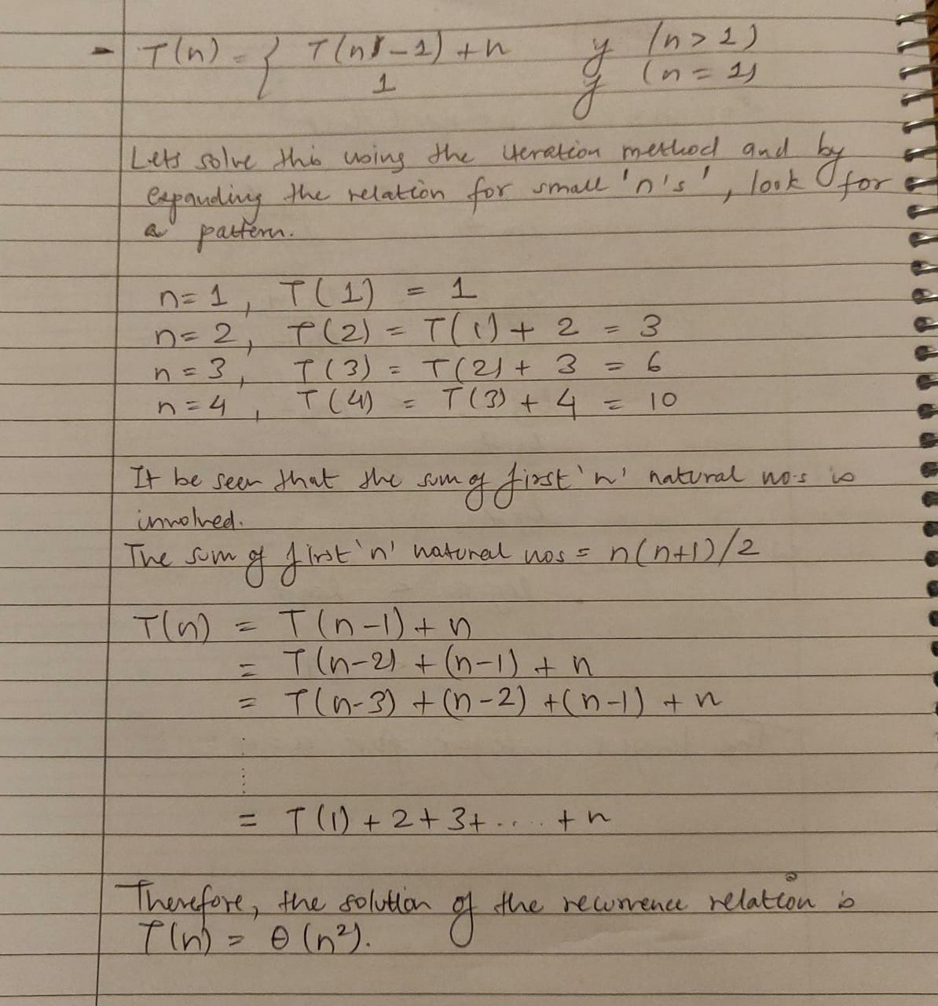

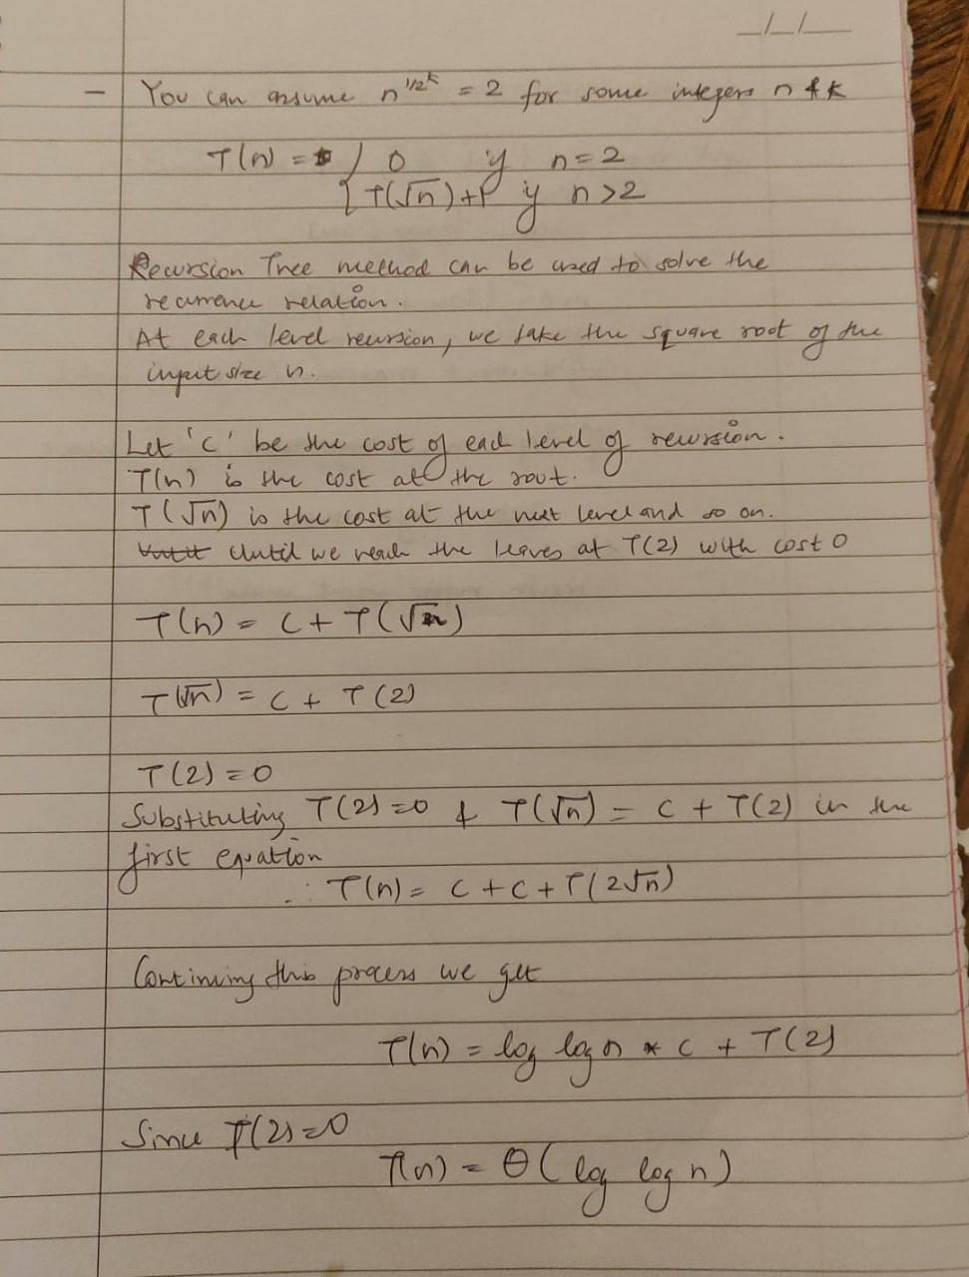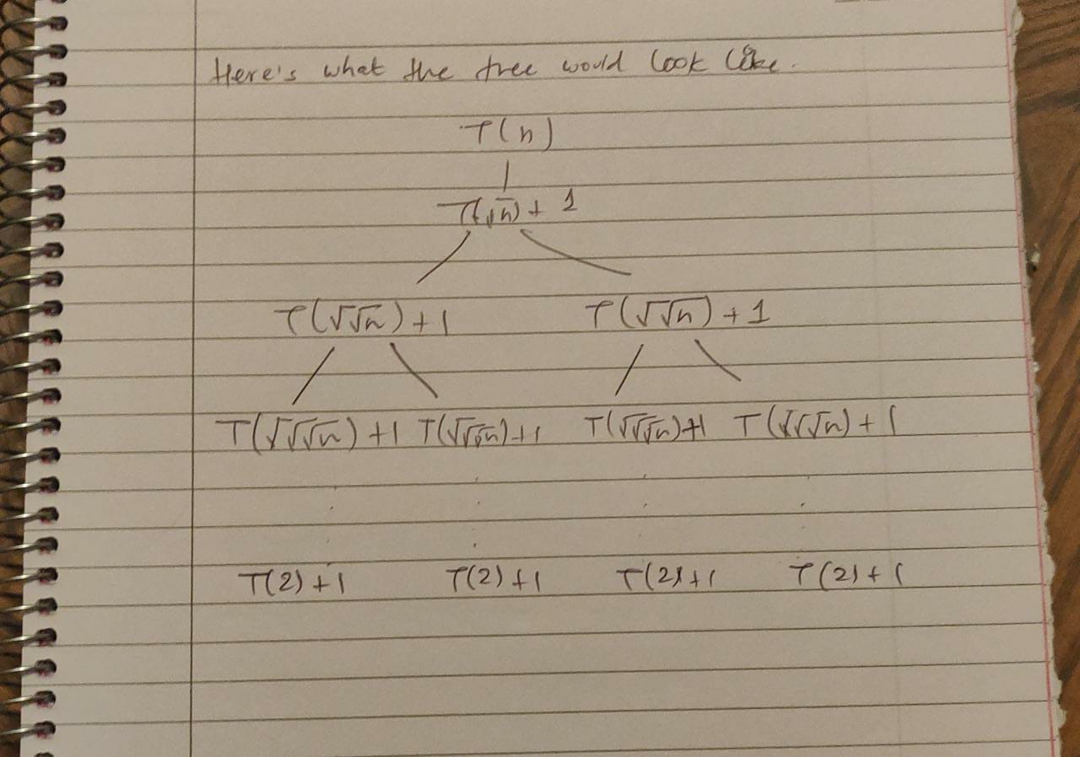

 

1. (6 points) Use Master method to solve *T*(*n*) = 4*T*(*n*/2) + *n*2 and T(1)=1.

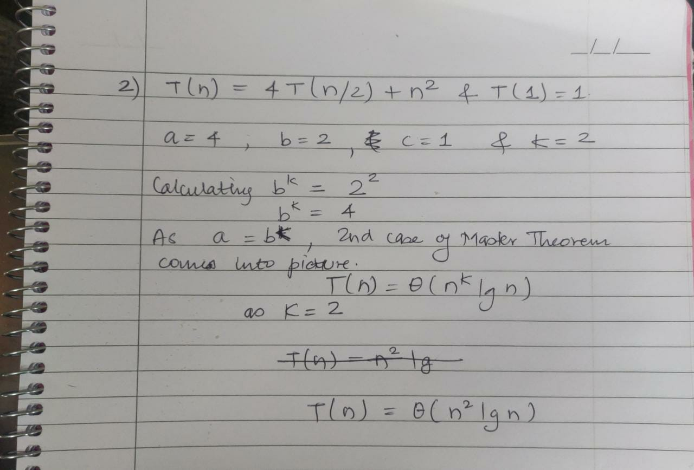

1. (10 points) Professor Caear wishes to develop a matrix-multiplication algorithm that is asymptotically faster than Strassen’s Algorithm. His algorithm will use divide-and conquer method, dividing each matrix into pieces of size n/4× n/4, and the divide and combine steps together will take 𝜃(𝑛2) time. He needs to determine how many subproblems his algorithm has to create in order to beat Strassen’s algorithm. If his algorithm creates a subproblems, then the recurrence for the running time T(n) becomes T(n) = aT(n/4)+ 𝜃(𝑛2). What is the largest integer value of a for which Professor Caesar’s algorithm would be asymptotically faster than Strassen’s algorithm?

